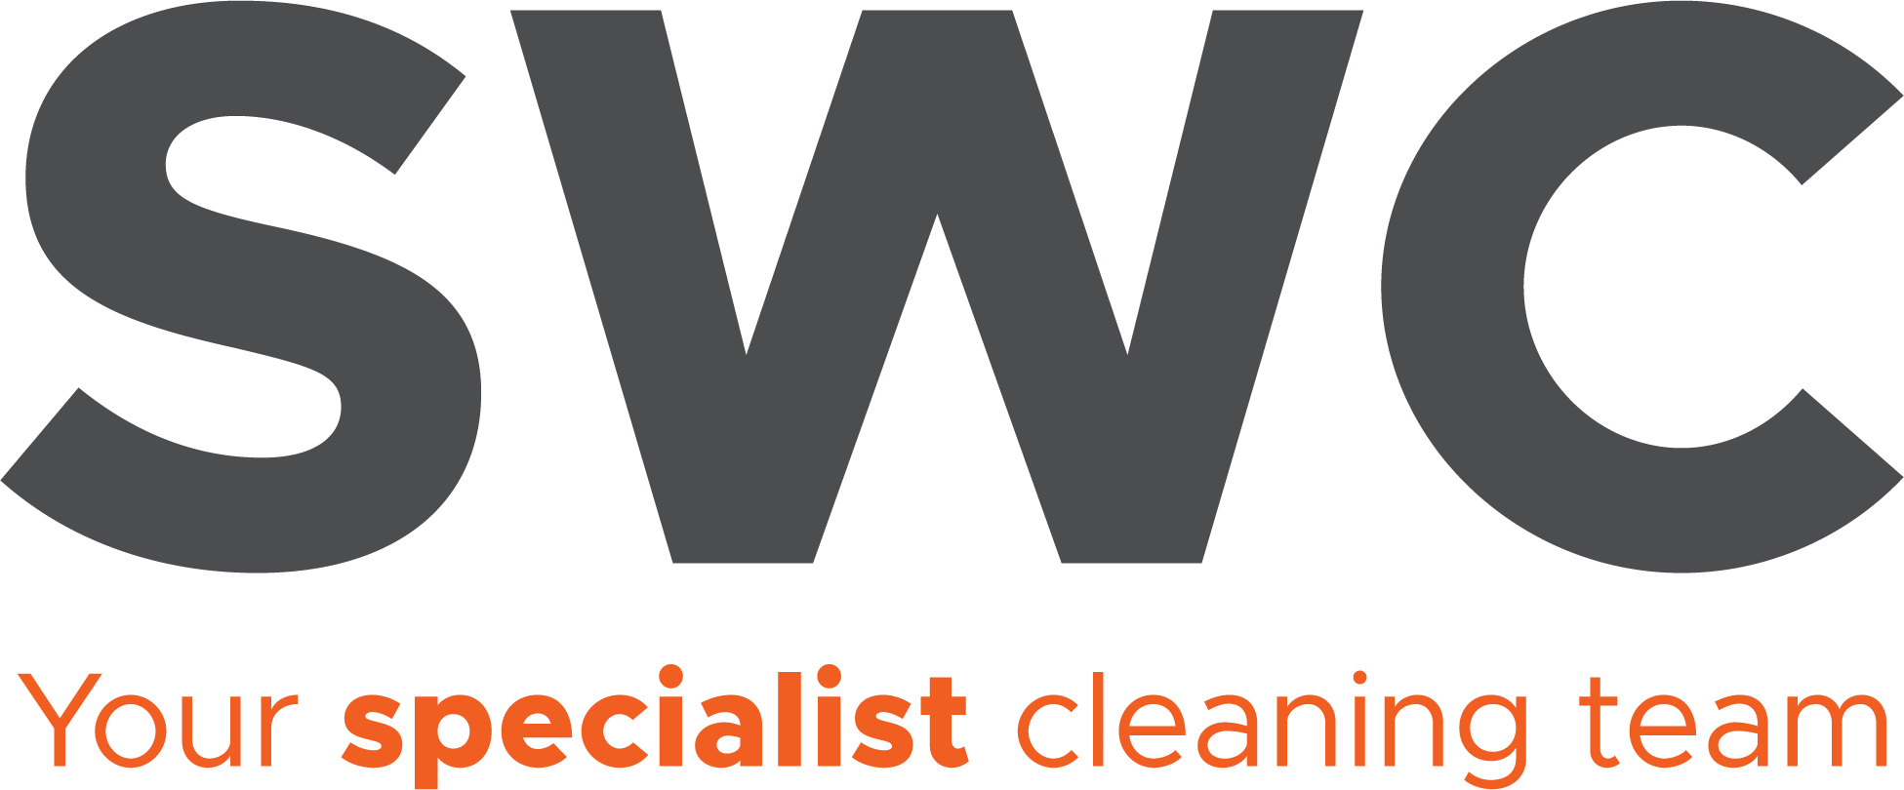

**Job Description**

**Rope Access technician – Level 2**

**Reports to:** Rope Access Manager/Supervisor

**Location:** London (Greater London)

**Salary:** £TBC

**Working Hours:** Monday – Friday (6am-2pm) - Flexible hours/weekend working occasionallyrequired.

**Employment Status:** Full Time, Permanent. 28 days of annual leave (including Bank Holidays)

**Other details:** Company vehicle may be provided subject to management approval. Candidate will be responsible for maintaining and keeping the vehicle clean.

**Purpose of the Role:** As an IRATA Level 2 Rope Access Technician, you will perform advanced rope access tasks under the supervision of a Level 3 Technician, ensuring safe and efficient operations. This role requires strong technical skills, experience with rescue techniques, and a proactive approach to workplace safety, whilst providing the highest levels of standards to all clients.

**Key Responsibilities**

* **Communication with Rope Access Manager –** Maintain regular updates with the Rope Access Manager regarding operations, safety concerns, and personnel performance.
* **Rope Access Operations –** Carry out rope access tasks, assisting in complex rigging setups and technical manoeuvres.
* **Safety Compliance –** Adhere to IRATA guidelines, ensuring all work is performed in line with safety standards.
* **Rescue Preparedness -** Execute rescue techniques as required and support emergency response procedures.
* **Equipment Maintenance –** Conduct daily pre-start equipment inspections, ensuring proper functioning and reporting any defects or necessary repairs.
* **Logbook Maintenance –** Maintain an accurate IRATA logbook, recording hours and completed tasks.
* **Reporting and Compliance (BigChange CRM) –** Utilize BigChange CRM for reporting, including photos of completed work, compliance checklists (i.e. pre-start inspections, toolbox talks), and adherence to operational standards.
* **Near-Miss Reporting –** Ensure all near-miss incidents are reported within 24 hours to improve safety and prevent future occurrences.

**Duties and Responsibilities:**

* Have full working knowledge of the areas in the building which are covered by the services run by SWC Ltd/OCS Group.
* To carry works scheduled by the supervisor or line manager in a timely, safe manor.
* A Level 2 technician role will be key to report on any defects and log works to the line manager, which will then be sent directly to the client.
* They will be required to report any near misses or accidents to the line manager and the on- site team.
* Ensure a high standard of personal hygiene and appearance and general cleanliness to comply with statutory and Company regulations, wearing company uniform as specified.
* Be aware of the condition of the equipment to ensure that all equipment is in safe working order, checked regularly and serviced. Report any faults to supervisor/ management.
* Comply with all Company & Client policies and statutory regulations relating to Health & Safety, safe working practices hygiene, cleanliness, fire and COSHH. This will include your awareness of any specific hazards in your workplace. Follow client/company guidelines with regards to the identification and reporting of health and safety hazards e.g., blocked/locked fire doors.
* Communicate well and demonstrate a pleasant, polite, efficient, caring and friendly service to customers and clients in all areas of service, which SWC Ltd provide.
* Report any customer complaints or compliments and take some remedial action if at all possible. Report immediately any incidents of accident, fire, theft, loss, damage or other irregularities to the Line Manager/ supervisor.
* Cover roles during periods of holidays and sickness.
* Comply with all SWC Ltd/OCS Group Company policies/procedures and client site rules and regulations.
* Carry out other reasonable tasks as directed by management.
* To attend any meetings or training courses.

**Key Result Indicators:**

* All cleaning and hygiene standards to meet service specification.
* Deliver a consistent level of service, within the Company's standards, to the contract specification and agreed performance levels.
* Comply with Company and statutory regulations relating to safe systems of work, health & safety, hygiene, cleanliness, fire and COSHH.

**Constraints:**

Please refer to the Clients’ site rules and procedures and the SWC Ltd (OCS Group) Employee Handbook.

**NB:** This job description is intended to give the post-holder an appreciation of the role envisaged and the range of duties and responsibilities to be undertaken. It does not attempt to cover every activity. Specific tasks and objectives will be agreed with the post-holder at regular intervals. The post-holder will be required, at all times, to perform any other reasonable task as requested by the Supervisor /Operations Manager, in order to meet the operational needs of the business.

**Person Specification:**

|  |  |
| --- | --- |
| **Qualifications, Experience & Competency** | |
| **Essential** | **Desirable** |
| **Attainments including qualifications:**   * IRATA Level 2 and relevant experience * Good standard of numeracy and literacy * Basic window cleaning experience | **Attainments including qualifications:**   * Any other working at height experience * Other health and safety * Clean valid driving British driving licence |
| **General intelligence:**   * Good decision-maker * Excellent negotiating skills * Willingness to take responsibility * Professional attitude with good general awareness * Friendly and helpful * Excellent communication and organisation skills * Ability to multi-task | **General intelligence:**   * Able to problem-solve |
| **Interests:**   * People orientated Interests: | **Interests:**   * Enjoys team activities |
| **Circumstances:**   * Flexible outlook * Confident team member | **Circumstances:**   * Keen to co-operate |
| **Special aptitudes:**   * Ability to learn quickly * Ability to interpret information * Awareness of need for strict confidentiality | **Special aptitudes:**   * Good attention to detail |
| **Disposition:**   * Hands-on approach * Positive outlook * Good sense of humour * Self-confident, resourceful and innovative * Copes well under pressure * Excellent social and interpersonal skills * Calm and methodical approach | **Disposition:**   * Keen to help out * Keen to learn, receive training and share knowledge |

**Declaration:**

I agree that I have been fully informed on my position and that my job description has been thoroughly explained to me.

**Employee’s signature:**

**Employees name:**  **Date:**

**(please print)**

**Managers signature:**

**Managers name:** **Date:**

**(please print)**